# CS 255 System Design Document Template

*Student: Margarita Kiseleva*

*Date: 02/22/2024*

## UML Diagrams

### UML Use Case Diagram

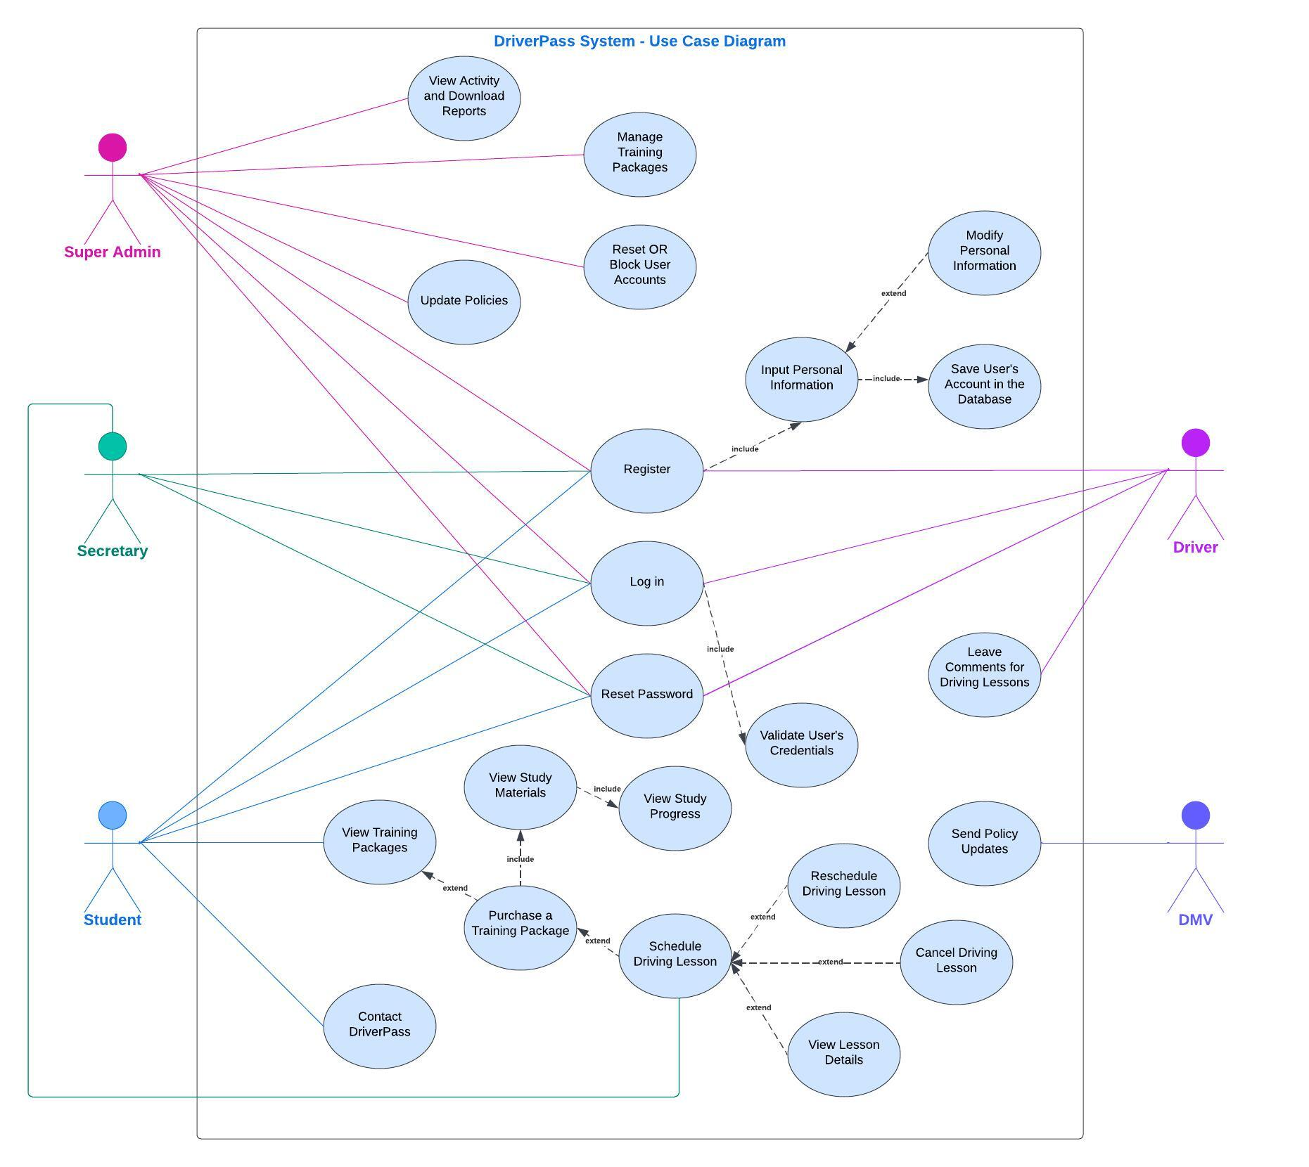

### UML Activity Diagrams

### UML Sequence Diagram (Training Package Purchase)

### UML Class Diagram

## Technical Requirements

***Hardware***

Developers’ laptops or PCs must be modern enough to support and effectively utilize the necessary software.

***Software***

Given that our goal is to make DriverPass available on various platforms and devices, I suggest that we choose Windows as our development platform. Windows is compatible with most of the tools needed for software development and most of the target platforms. This will help us expand DriverPass to various computing environments.

***Server***

Knowing that the client is not interested in dealing with back-up and security issues, I suggest that we make the DriverPass system cloud-based, which will take care of the necessary databases required for the system’s back end as well as the security operations. Cloud will also help to make the system more scalable by implementing load balancing for an even distribution of incoming traffic.

***Development and QA***

Web-based apps for Windows are normally created with JavaScript, Python, and such languages as C# for the back end, and HTML/CSS/JavaScript for the front-end. The most recommended IDEs for programming on Windows are Visual Studio, NetBeans, JetBrains Rider, and IntelliJ IDEA. Depending on the coding language chosen for the system development, appropriate testing frameworks must be utilized throughout the development process.

***Security***

The DriverPass system must incorporate robust security features to make sure that user’s sensitive information remains confidential. Data encryption protocols, such as HTTPS, must be utilized to secure data transmission. The system must also have reliable authentication and authorization mechanisms to distinguish between different types of users, provide appropriate access rights, and open adequate system functionality***.*** It is also recommended that regular security audits are conducted to identify and timely address potential security risks and detect system vulnerabilities at an early stage of their development.

***Network***

DriverPass’ system development and maintenance will require speedy and reliable Internet connection. Such a reliable connection to the network will also ensure that the system is available and responsive to its users. Additionally, we must remember that the DriverPass system will have two types of updates performed: regular and of need. Regular updates will be run every 20-40 days. Of need updates will take place in case a bug is detected, or a new feature is released. Thus, a reliable Internet connection will ensure that all the necessary updates are run timely.

***Documentation***

It is important to make sure that the developing company creates detailed technical documentation for the system. Such documentation may include architecture diagrams, application programming interface supporting documents, consistent and concise comments throughout the code. Additionally, the developing company must provide the client with a user manual so that the DriverPass employees can be properly trained in using the system.

***System Maintenance***

The developing company must establish a plan for regular system updates and patching, which will cover security vulnerabilities and make sure the system’s functionality is optimal.

***Customer Support***

The developing company must create a user-friendly and effective system of customer support so that all the users of DriverPass can have their issues resolved and inquiries addressed in a timely manner.